Project Executable Files

Date | 15 March 2026
Team ID | xxxxxx
Project Name | xxxxxx
Maximum Marks | 3 Marks

Project Executable Files
This section requires submission of all executable and deployable files for your project. Ensure all files are properly organized, named, and uploaded to the specified submission platform. The evaluator must be able to run or deploy your solution using the provided files and instructions.
Step 1: Submission Checklist

S.No | Item to Submit | Submitted (Yes / No / NA)
1 | Complete source code (all files and folders) | YES
2 | README / Setup Guide (instructions to run the project) | YES
3 | requirements.txt / package.json / dependency file | YES
4 | Database schema / seed files (if applicable) | YES
5 | Environment configuration file (.env.example or similar) | YES
6 | Deployed application URL (if hosted) | YES
7 | APK / Executable binary (if applicable for mobile/desktop apps) | NO
8 | Dockerfile / Containerization config (if applicable) | NO
9 | Test files and test results | YES
10 | Demo video or walkthrough (if required) | YES

Step 2: File / Folder Structure
Provide an overview of your project's file and folder structure below:
/OptiCrop
/backend
/frontend
/models
/database
requirements.txt
README.md

Step 3: Deployment / Access Details

Field | Details
Hosted / Deployed URL | https://verbose-waffle-6vvgv4vwwv9x275j-5000.app.github.dev
Login Credentials (Demo) | No login credentials required (Direct access enabled for evaluation)
Platform / Hosting Provider | IBM Cloud
Repository Link | https://github.com/sheikjaheer2914-ai/sheikjaheer2914-ai-OptiCrop-Smart-Agricultural-Production-Optimization-Engine-project
Demo Video Link | https://youtube.com/demo

Step 4: Run Instructions
Provide clear, step-by-step instructions for the evaluator to run your project locally:
• Install Python
• pip install -r requirements.txt.
• Run backend
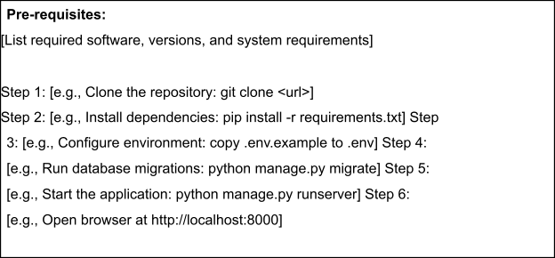
• Run frontend.
• Open browser

Step 5: Known Issues / Limitations

S.No | Known Issue / Limitation | Workaround / Status
1 | Needs internet
2 | Limited dataset
3 | Basic UI

